Table Group Ch. 3 question
Table Group 1: a
Table Group 2: b (null?)
Table Group 3: c
Table Group 4: d
Table Group 5: e
Table Group 6: f

a. Describe the observation Monod made as a result of his experiment, which is illustrated by Figure 3.2.
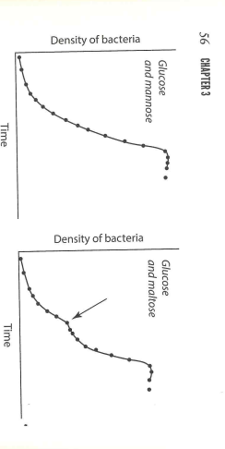

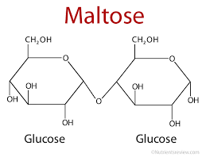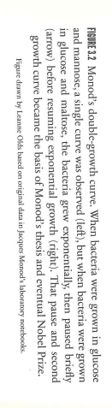
b. Write the hypothesis Monod proposed to explain his observation.

c. Briefly outline the method Monod designed to test his hypothesis.

d. Write the prediction Monod made for what he expected to see if his hypothesis was supported.

e. Using a model similar to those found on page 68 of The Serengeti Rules, show how the tryptophan operon regulatory system works.
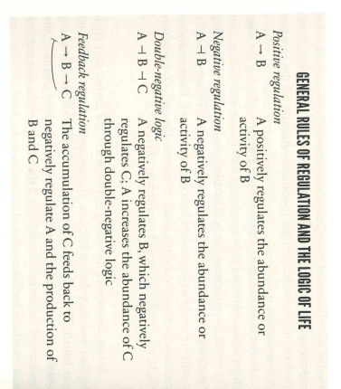
f. Using Figure 3.6 on page 70 for inspiration, construct a model for how tryptophan regulates its own synthesis.

its.