AP Biology
GENETIC DISORDER PROJECT- Evaluation Sheet

Presenter Name: _____________________________________
Evaluator Name: _____________________________________
--INFORMATION SHEET/RUBRIC
Your assignment is to obtain information on the genetic disorder/disease of your choice. To prevent duplication, be sure to sign your name next to the disorder/disease sheet on the Google sheet for this class period. Post final Google Slide show on class slide show.
DUE February 27 BOP.
8 pts. Q/E/SP
Big Idea 3.A.3
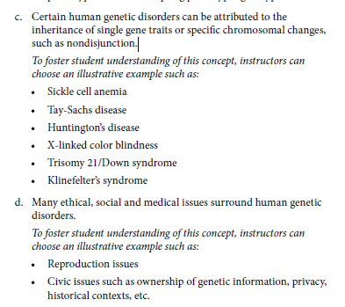
You should include the following:

(1)A. Name of disorder: ______________________________
- Brief description of the disorder. What is it?
(1)B. Cause/pattern of inheritance (which of the following?)
Explain what is thought to cause this disorder. Try to be specific.
- Is it an autosomal dominant gene?
- Is it an autosomal recessive gene?
- Is it a sex-linked gene?
- Is it a result of non disjunction?
- Is it inherited in some other way?

(1)C. Facts about the disease
- How often does this occur in the population?
- Is it more frequent among men or women?
- Is it more common in one ethnicity?

(1)D. Symptoms
- What are the symptoms of a person who has this condition?
- What are some of the daily challenges faced by the individual and family?

(1)E. Testing and Screening
- What kinds of tests can determine whether a person has the condition or not?

(1)F. Treatment
- What types of treatments are available for persons who have been confirmed to have the disease?
- Is the disease life-ending?
(1)G. Interesting facts
- Include at least 3 interesting facts

(1)H. Picture/illustration/diagram related to the disorder
- Include a pedigree chart to show possible patterns of inheritance
- Include a Punnet square to show patterns of inheritance
- If non applicable explain why not.

(1)I. At least 2 peer-reviewed cited sources- MLA format

(2)J. Provided commentary/overview of current research relating to this disorder.

(1)K. Kept eye contact with the audience, voice can be heard, and was able to answer questions

(3)M. Clearly explained some of the social, ethical and medical issues associated with this disorder?

(1)N. Thoughtful/insightful response to Q & A questions posted to group in Google Slides

___/16 pts/2 = ____8pts Q/E/SP

