AP Biology – DNA Replication

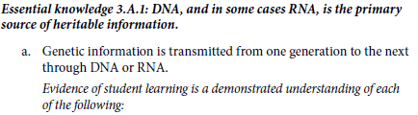
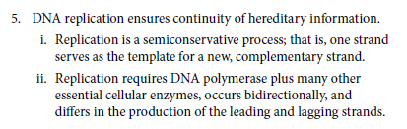
How is DNA able to replicate itself?
Using paperclips and Post-it paper develop a model that shows the process of DNA replication. Be able to explain the process and how the following terms/concepts relate to your model. Use two different colors to differentiate parent and daughter strand.

3’ end
5’ end
antiparallel
Base pairing rule
Complementary
daughter DNA strand
single-strand binding proteins
DNA ligase
DNA polymerases
Helicases
lagging strand
leading strand
Okazaki fragments
origins of replication
Parental DNA strand
Primase
Primer
replication bubble
replication fork
semiconservative replication model
conservative replication model
dispersive replication model
Topoisomerase
- Be able to relate the process of DNA replication to steps in the cell cycle.
- What mechanism is there to reduce the number of mistakes when copying DNA?
- What is the biological function of telomeres?

